**ASSIGNMENT-1**

**1.progarm to print N natural numbers**

**Pseudocode**

begin

Declare i,n

Enter n

i=1

use forloop to print numbers upto n

print i

end

**c program**

#include<stdio.h>

void main()

{

int i,n;

printf("enter n:");

scanf("%d",&n);

for(i=1;i<=n;i++)

{

printf( "%d\n",i);

}

}

**Output**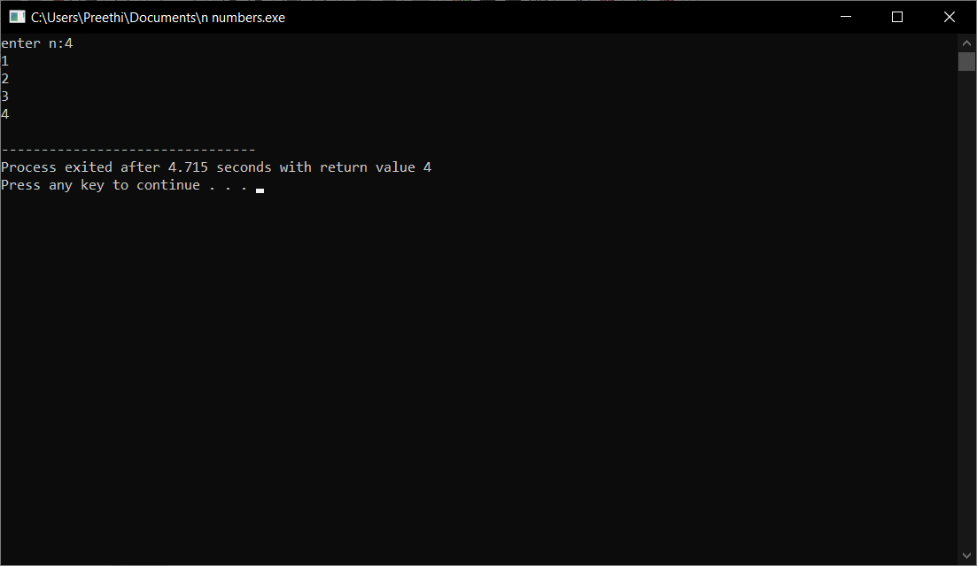

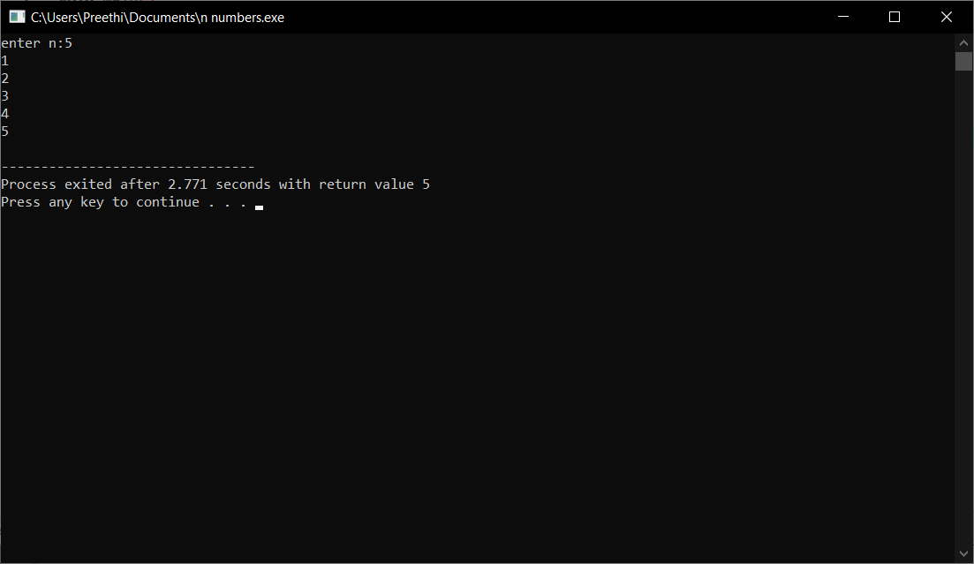

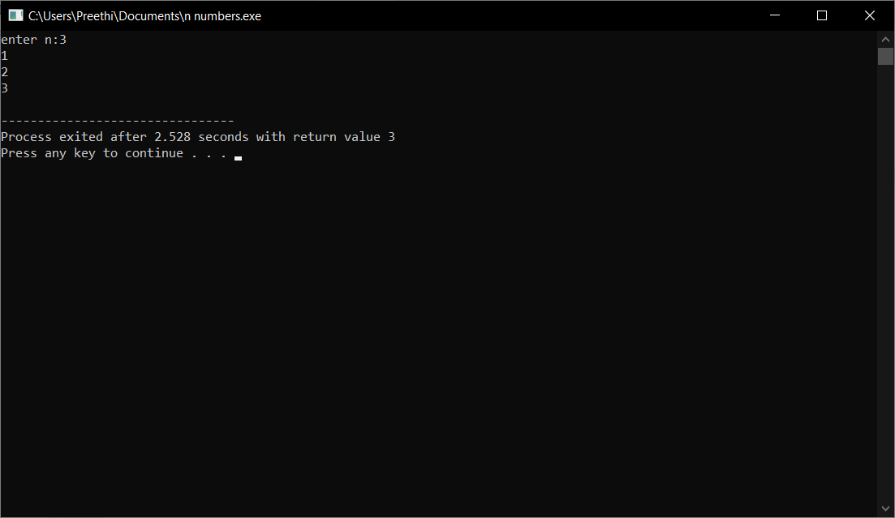

**2.program to print sum of N natural numbers.**

**Pseudocode**

Begin

Declare i n sum=0

Input n

i=0

use for loop for following steps

sum=sum+i

i=i+1

till the value of i<=num

print sum as the sum of numbers

end

**c program**

#include<stdio.h>

int main()

{

int n,i,sum=0;

printf("enter n:");

scanf("%d",&n);

for(i=1;i<=n;i++)

{

sum=sum+i;

}

printf("%d\n",sum);

return 0;

}

**Output**

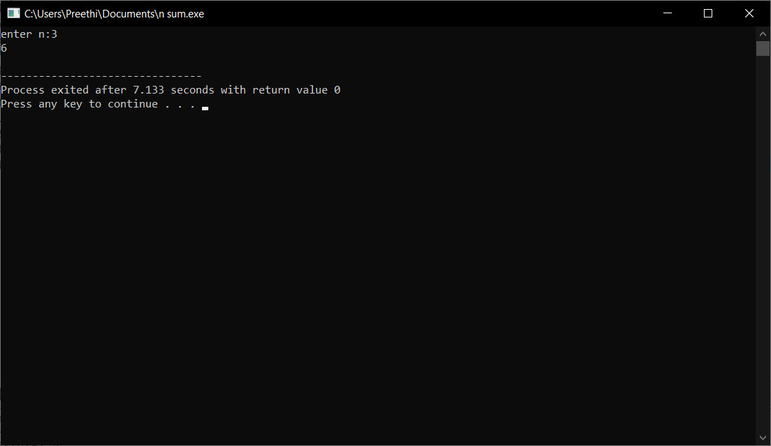

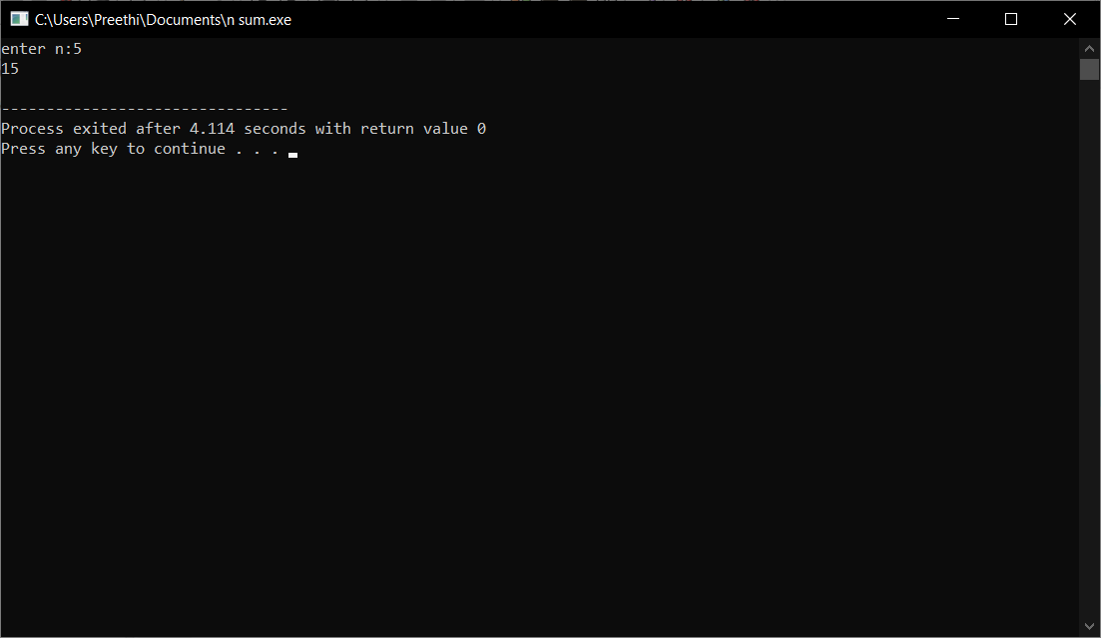

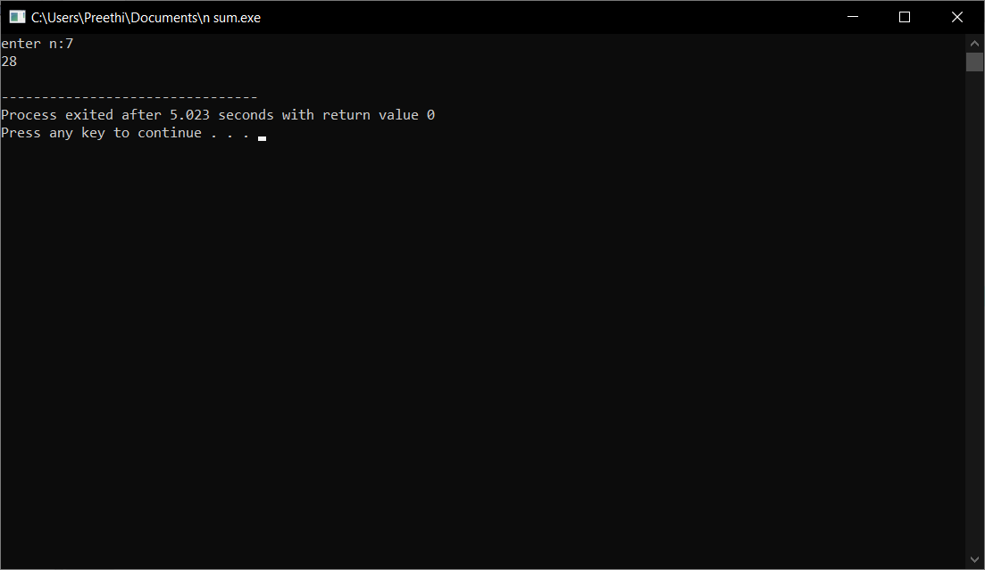

**3. Program to print multiplication Table of a given number ( N). Example : if N==5 5 * 1 = 5 5 * 2 = 10 : : : : : : : : 5 * 10 = 50**

**Pseudocode**

Begin

Declare i,n

Input n

Use forloop for following step upto 10

For(i=1;i<=10;i++)

Printn (n*i)

end

**C program**

#include<stdio.h>

void main()

{

int i,n;

printf("enter n:");

scanf("%d",&n);

for(i=1;i<=10;i++)

{

printf("%d * %d= %d\n",n,i,n*i);

}

}

**Output**

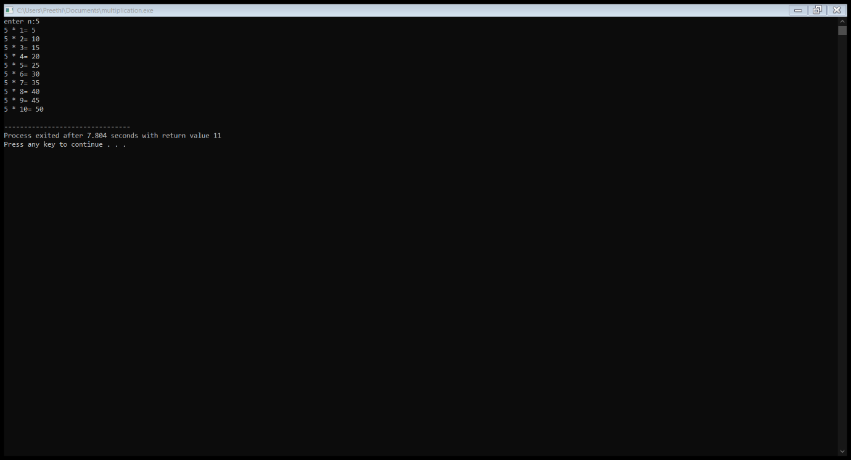

**4. Program to check a given number is perfect number or not.**

**Pseudocode**

Begin

Initialize i,n,sum=0

Input n

Run a loop from 1 to n by increment 1 in each iteration

For(i=1;i<=n;i++)

If(n%i==0) add i to sum

If sum==n print perfect number

Else print not a perfect number

end

**C program**

#include<stdio.h>

void main()

{

int n,i,sum=0;

printf("enter n");

scanf("%d",&n);

for(i=1;i<n;i++)

{

if(n%i==0)

sum=sum+i;

}

if(sum==n)

{

printf("perfect number %d",n);

}

else

{

printf("not a perfect number %d",n);

}

}

**Output**

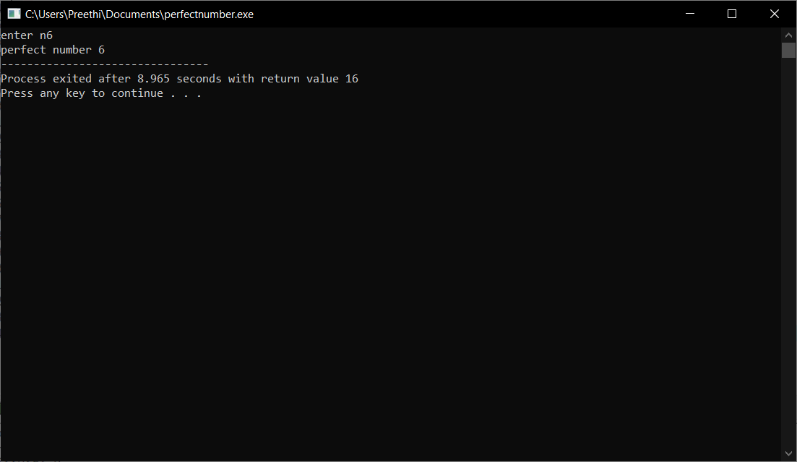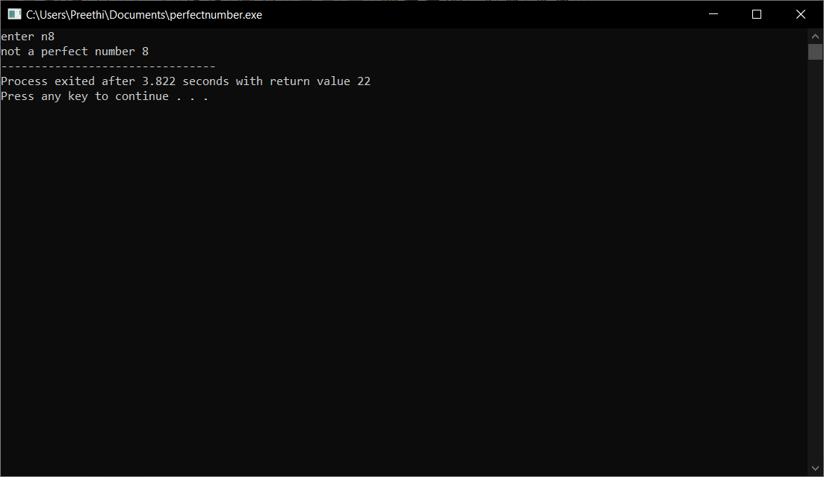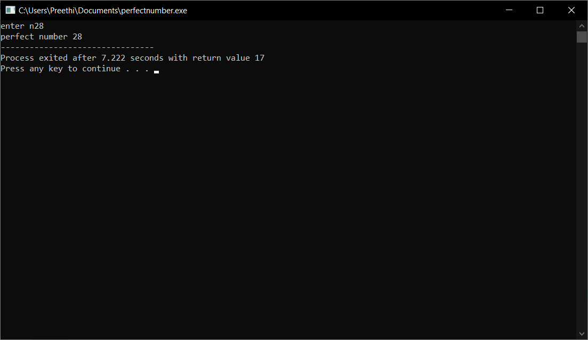

**5. program to print perfect numbers below given ‘N’.**

**Pseudocode**

Begin

Declare i,n,sum=0,j

Input n

Run loop from 1 to n by increment 1 in each iteration

Run another loop for(j=1;j<i;j++)

If(i%j==0) sum =sum+i

If(sum==i)print number

End

**C program**

#include<stdio.h>

void main()

{

int i,n,sum,j;

printf("enter n;");

scanf("%d",&n);

for(i=1;i<=n;i++)

{

sum=0;

for(j=1;j<i;j++)

{

if(i%j==0)

{

sum=sum+j;

}

}

if (sum==i)

{

printf("perfect number%d\n",i);

}

}

}

**Output**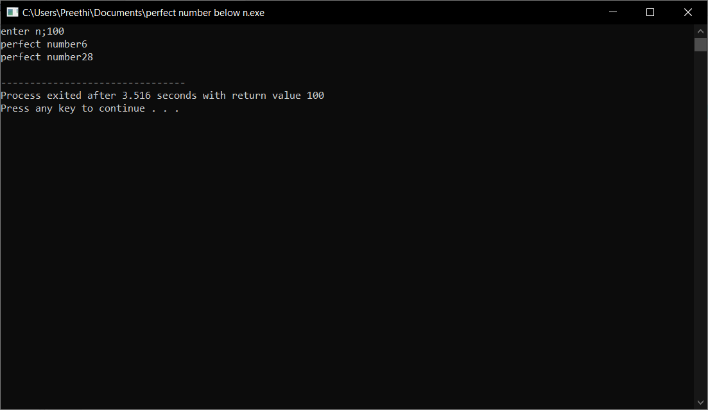

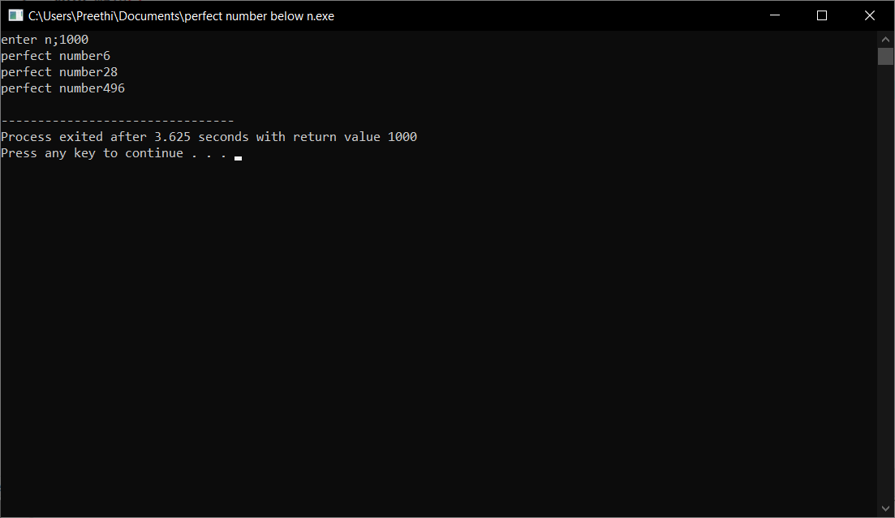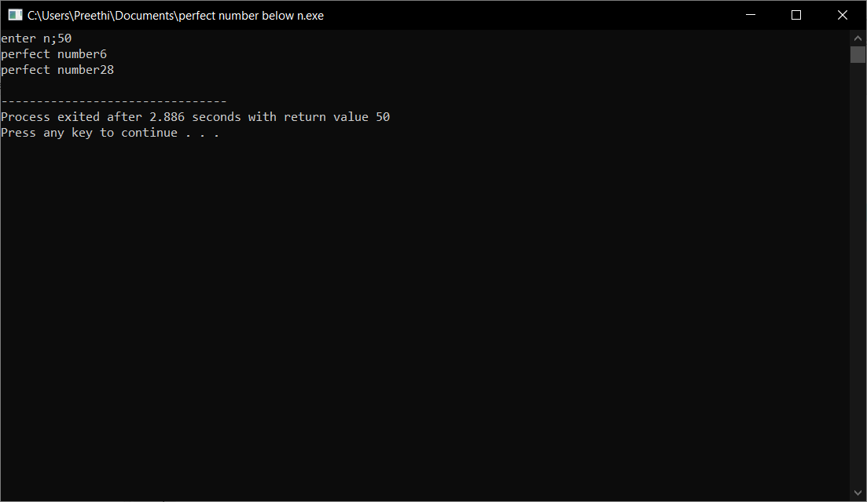

**6. Program to print sum of digits of a given number.**

**Pseudocode**

Start

Declare r,n,sum

Input n

While n>0

Take the remainder r of the number

n%10

add remainder r to sum

sum=sum+r

Divide the number by 10

n=n/10

repeat untill n<0

print sum

end

**c program**

#include<stdio.h>

void main()

{

int r,sum,n;

printf("enter n:");

scanf("%d",&n);

while(n>0)

{

r=n%10;

sum=sum+r;

n=n/10;

}

printf("sum of digits is:%d",sum);

}

**Output**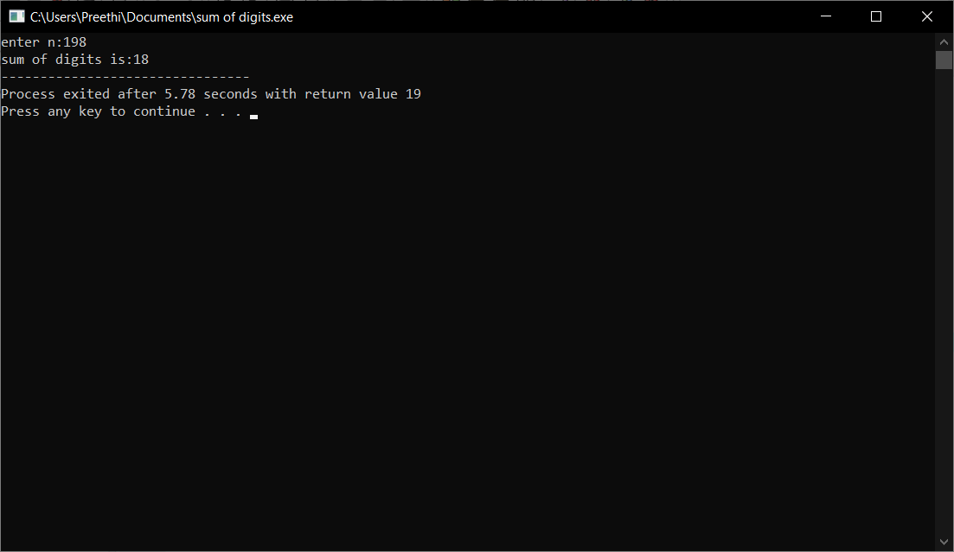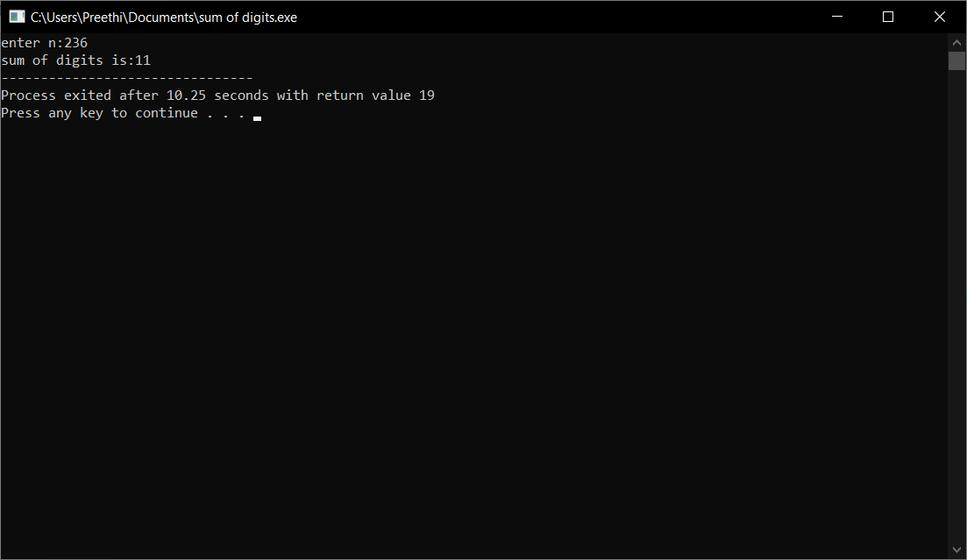

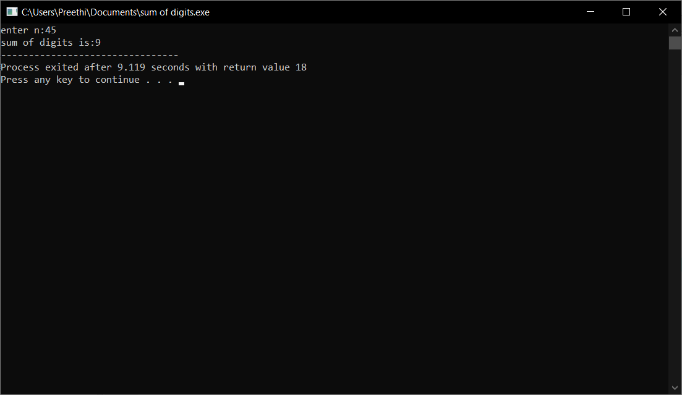

**7. Program to check the given number is palindrome or not.**

**Pseudocode**

Begin

Declare n,rev=0,rem,temp

Input n

Store n in temp temp=n

Get rem by n%10

Add rem to rev*10

rev=rev*10+rem

Divide number by 10

n=n/10

repeat until n<0

if temp==rev print palindrome

else print not a palindrome

**C program**

#include<stdio.h>

void main()

{

int n,rev=0,rem,temp;

printf("enter n");

scanf("%d",&n);

temp=n;

while(n>0)

{

rem=n%10;

rev=rev*10+rem;

n=n/10;

}

if(temp==rev)

{

printf("palindrome");

}

else

{

printf("not palindrome");

}

}

**Output**

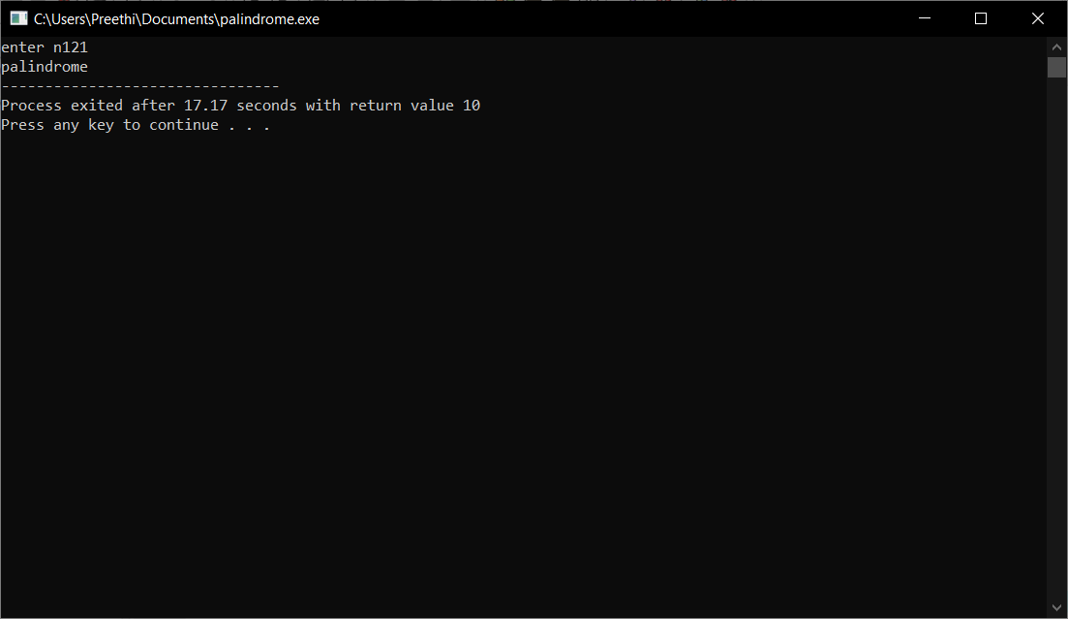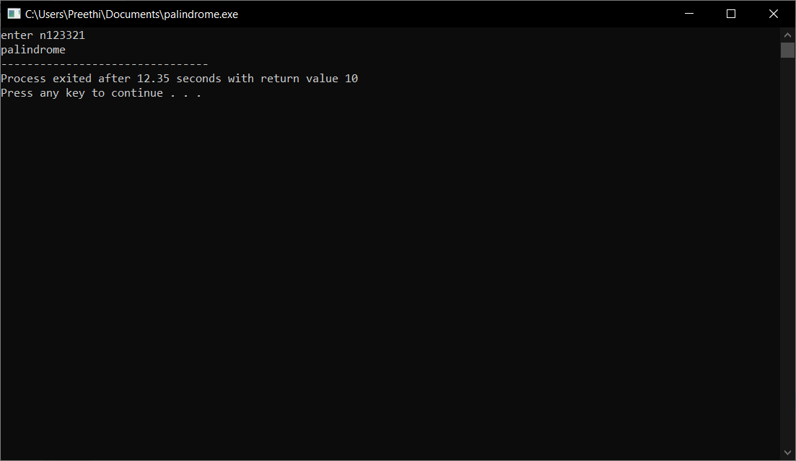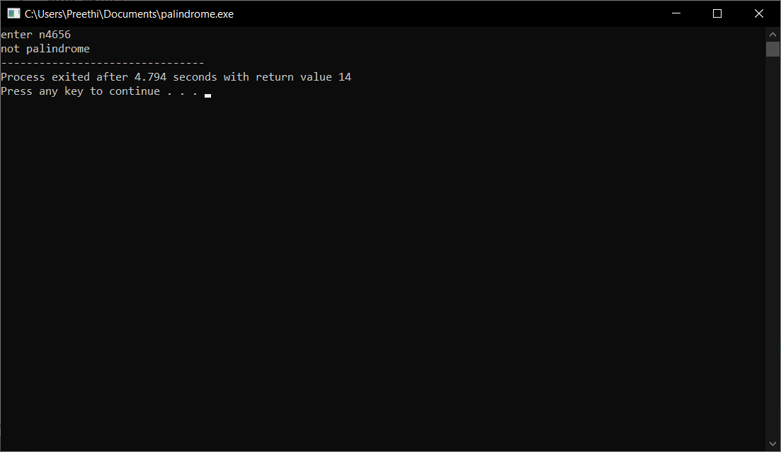

**8. program to print factorial of a given number.**

**Pseudocode**

Initialize i,n,fact=1

Input n

Run loop from 1 to n

For(i=1;i<=n;i++)

Fact=fact*i

Print fact

end

**C program**

#include<stdio.h>

void main()

{

int i,n,fact=1;

printf("enter n:");

scanf("%d",&n);

for(i=1;i<=n;i++)

{

fact=fact*i;

}

printf("%d",fact);

}

**Output**

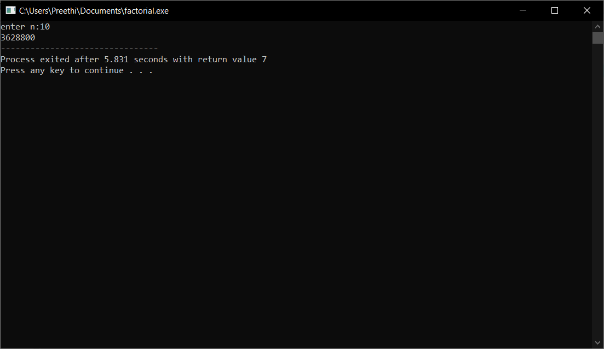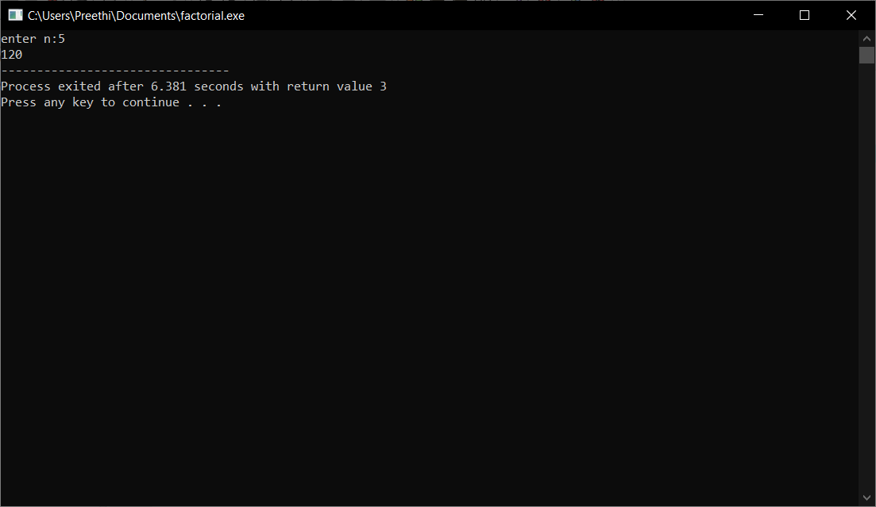

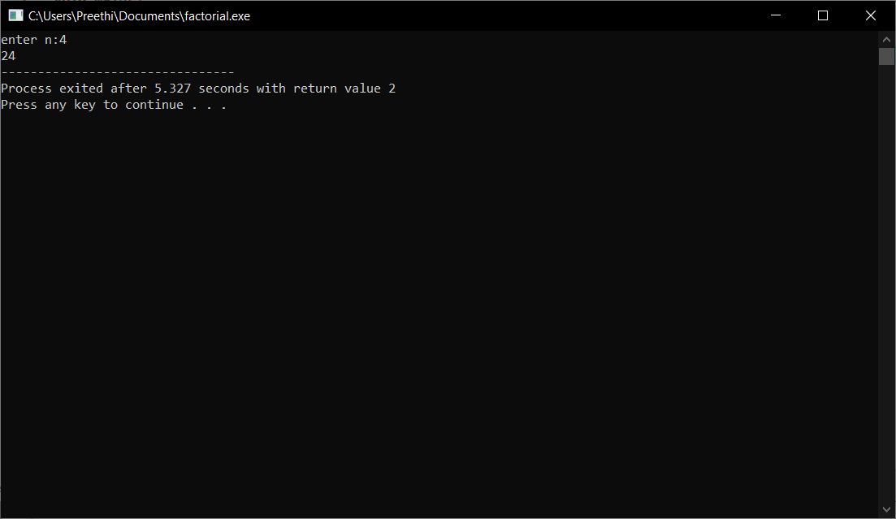

**9. program to check whether given number is prime or not.**

**Pseudocode**

Begin

Declare i,n count=0

Input n

Run loop from 1 to n by increment 1 in each iteration

For(i=1;i<=n;i++)

If(n%i==0)count++

If(count==2)print prime

Else print not a prime

end

**C program**

#include<stdio.h>

void main()

{

int i,n,count=0;

printf("enter n:");

scanf("%d",&n);

for(i=1;i<=n;i++)

{

if(n%i==0)

{

count++;

}

}

if(count==2)

{

printf(" prime");

}

else

{

printf(" not prime");

}

}

**Output**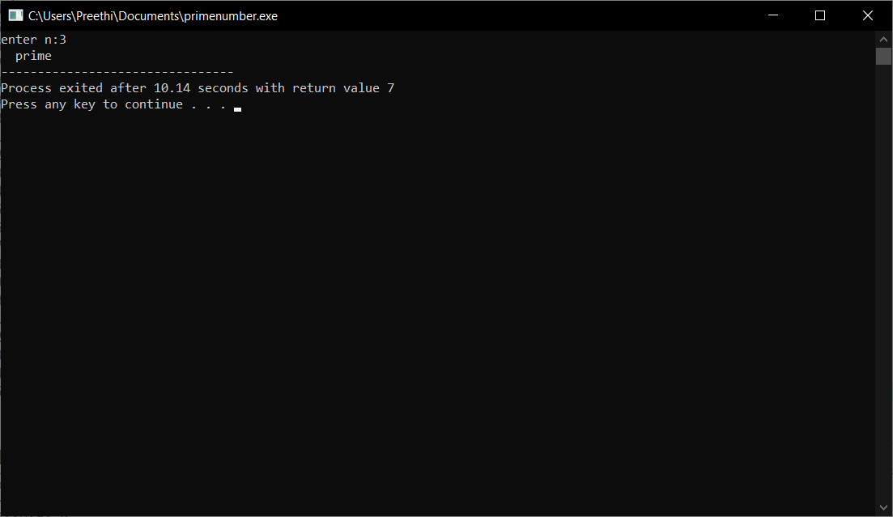

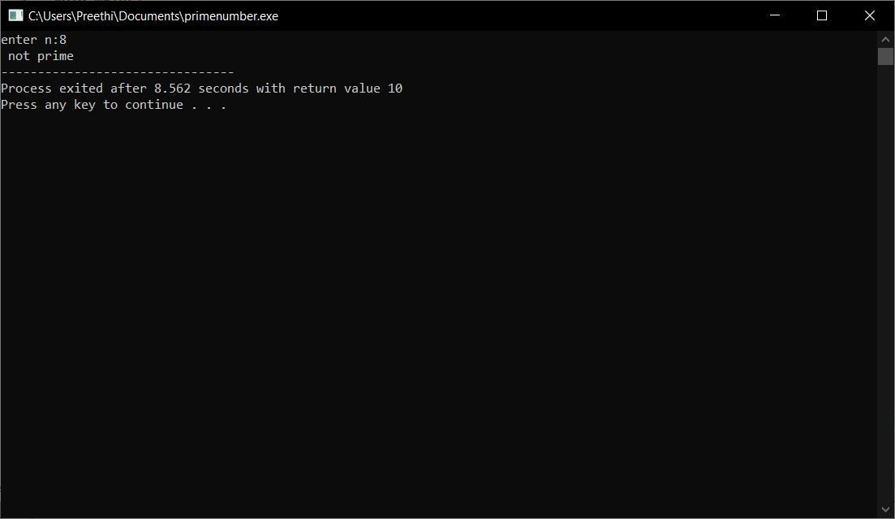

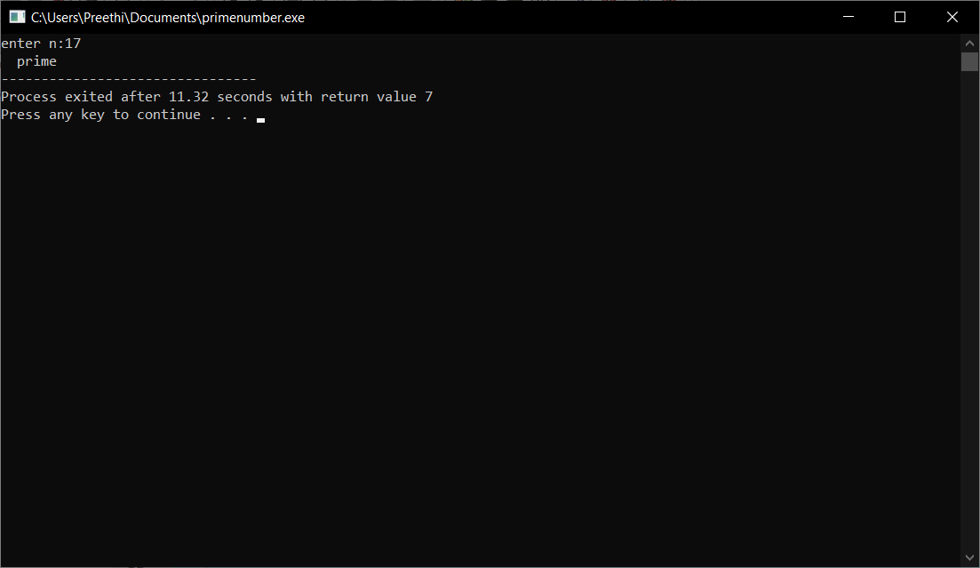

**10 . program to print all prime numbers below given ‘N’.**

**Pseudocode**

Start

Declare i,n,count=0,j

Input n

Runloop from 1 to n

For(i=1;i<=n;i++)

For(j=1;j<=i;j++)

If(i%j==0)count++

If(count==2)print i

end

**C program**

#include<stdio.h>

int main()

{

int n,i,j,count;

printf("enter n:");

scanf("%d",&n);

for(i=1;i<=n;i++)

{

count=0;

for(j=1;j<=n;j++)

{

if(i%j==0)

{

count++;

}

}

if(count==2)

{

printf("%d\n",i);

}

}

return 0;

}

**Output**

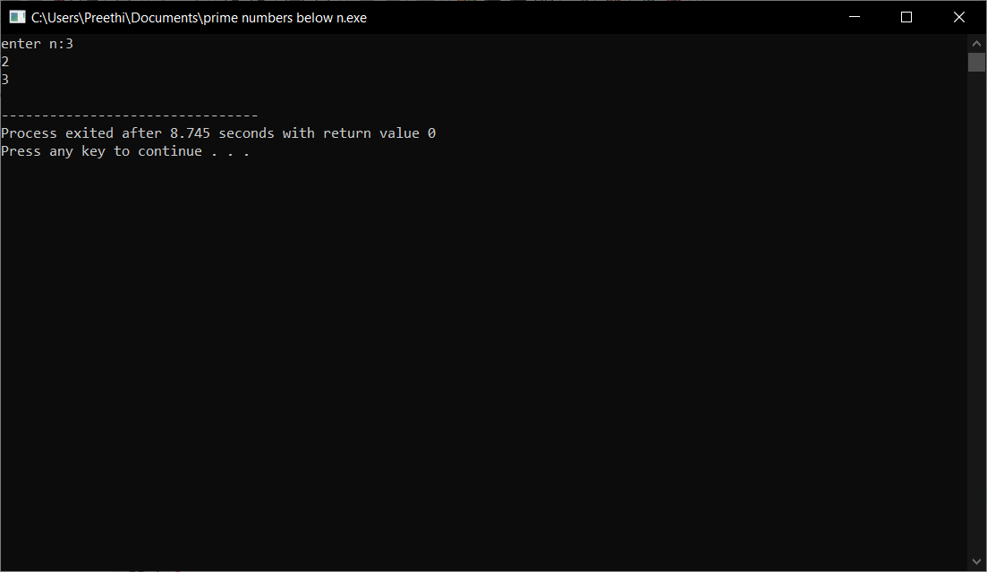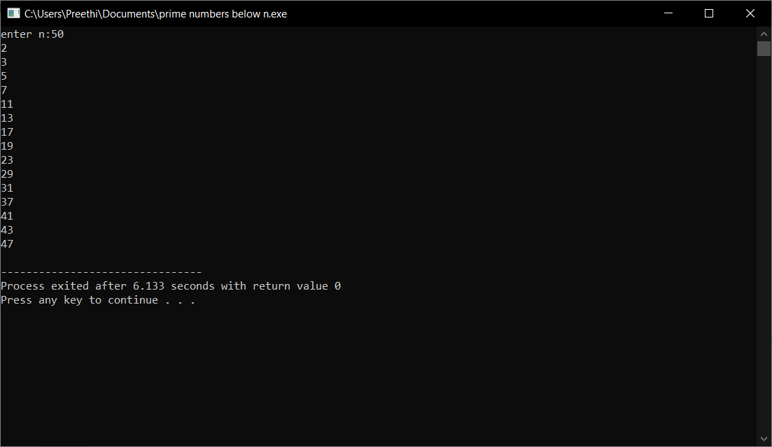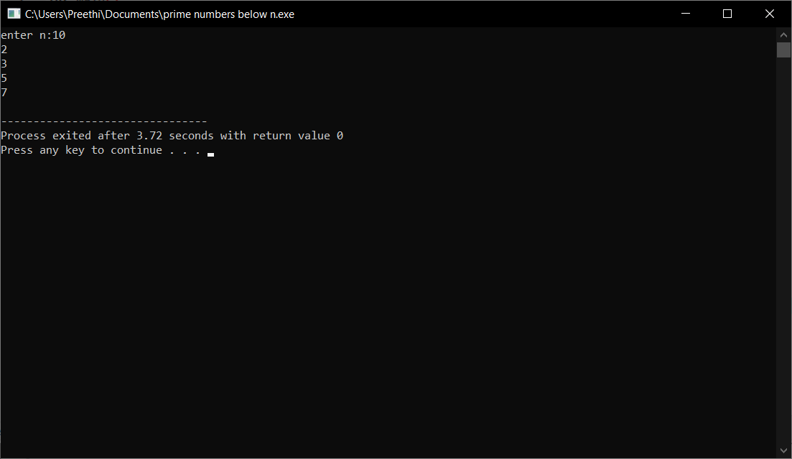

**11. program to print fibonacci series till a given value ‘N’.**

**Pseudocode**

Start

Declare n,i,n1=0,n2=1

Input n

Print n1,n2

Use forloop for following steps

for(i=0;i<n-2;i++)

nth =n1+n2

n1=n2

n2 =nth

print(nth)

end

**C program**

#include<stdio.h>

int main()

{

int n,i;

int nth;

int n1=0;

int n2=1;

printf("enter n:");

scanf("%d",&n);

printf("%d\n%d\n",n1,n2);

for(i=0;i<n-2;i++)

{

nth=n1+n2;

printf("%d\n",nth);

n1=n2;

n2=nth;

}

return 0;

}

**Output**

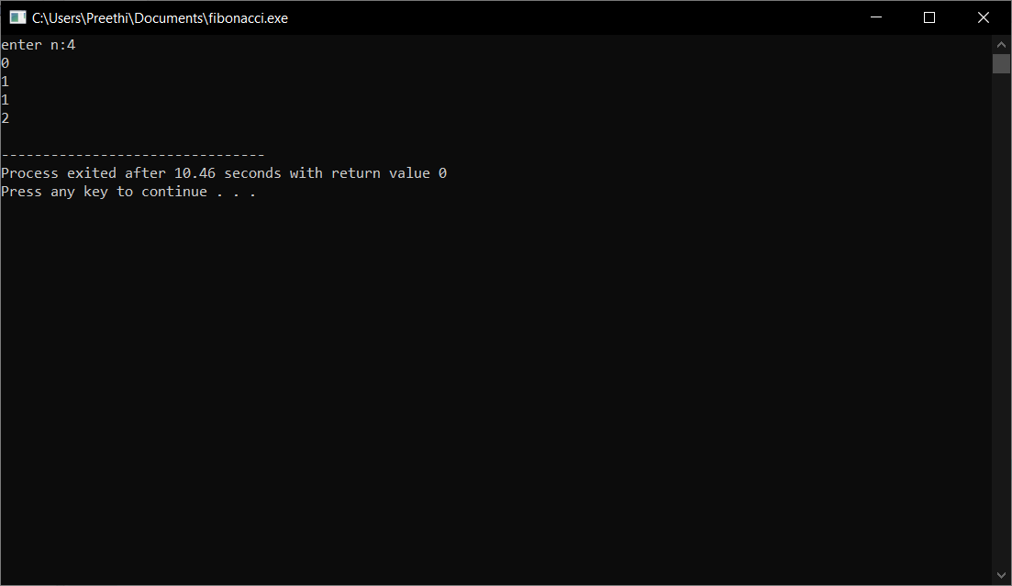

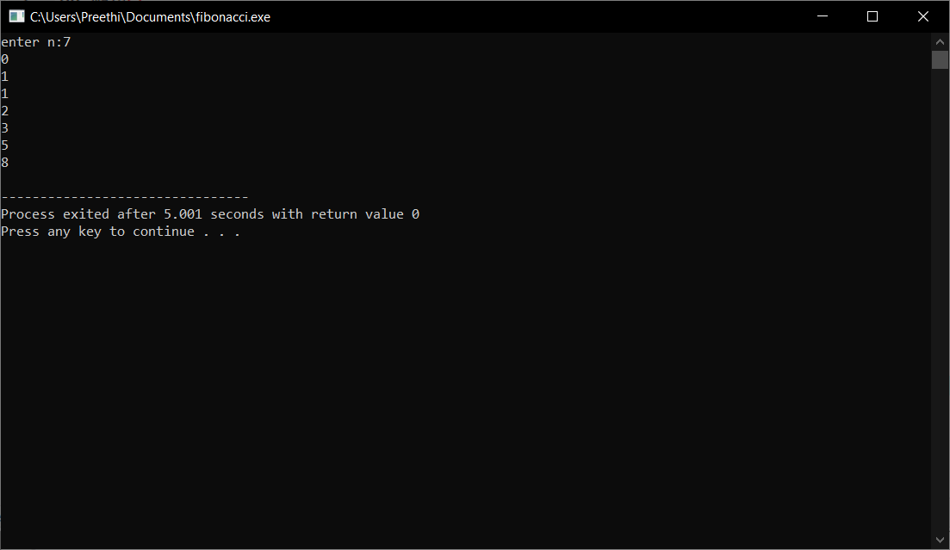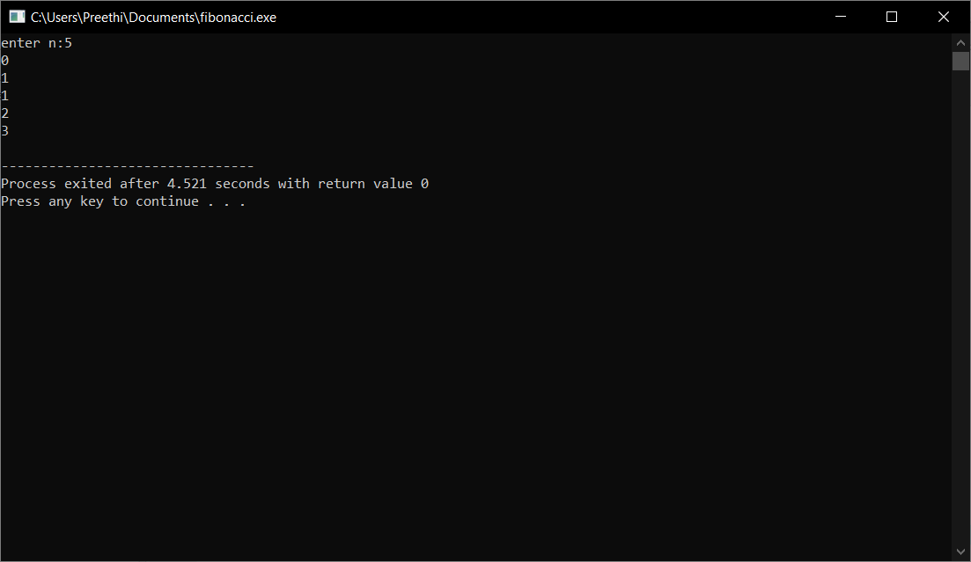

**12. print pyramids and patterns as below**

**1**

**1 2**

**1 2 3**

**1 2 3 4**

**1 2 3 4 5**

**Pseudocode**

Start

Declare i,j

Using forloops for the following

for(i=1;i<=5;i++)

for(j=1;j<=1;j++)

print(j)

end

**C program**

#include<stdio.h>

void main()

{

int i,j;

for(i=1;i<=5;i++)

{

for(j=1;j<=i;j++)

{

printf("%d ",j);

}

printf("\n");

}

}

**Output**

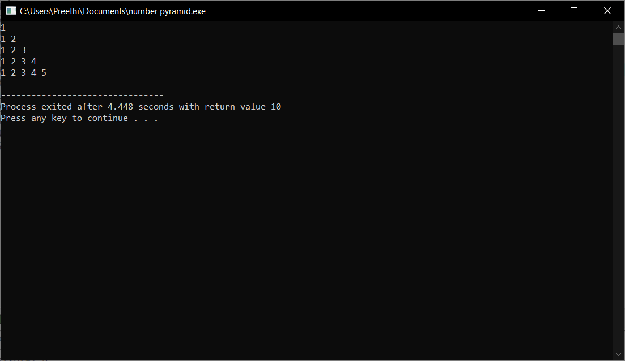

**13.print the following pyramid**

**1**

**2 2**

**3 3 3**

**4 4 4 4**

**5 5 5 5 5**

**Pseudocode**

Begin

Declare i,j,n,space=1

Input n to print number of rows

Run loop from 1 to n

Use loop to print space

for(space=1;space<=n-i;space++)

print(“ “)

for(j=1;j<=i*2-1;j++)

print i

end

**C program**

#include<stdio.h>

main()

{

int i,space=1,j,n;

printf("enter n: ");

scanf("%d",&n);

for(i=1;i<=n;i++)

{

for(space=1;space<=n-i;space++)

printf(" ");

for(j=1;j<=i*2-i;j++)

printf("%d ",i);

printf("\n");

}

}

**Output**

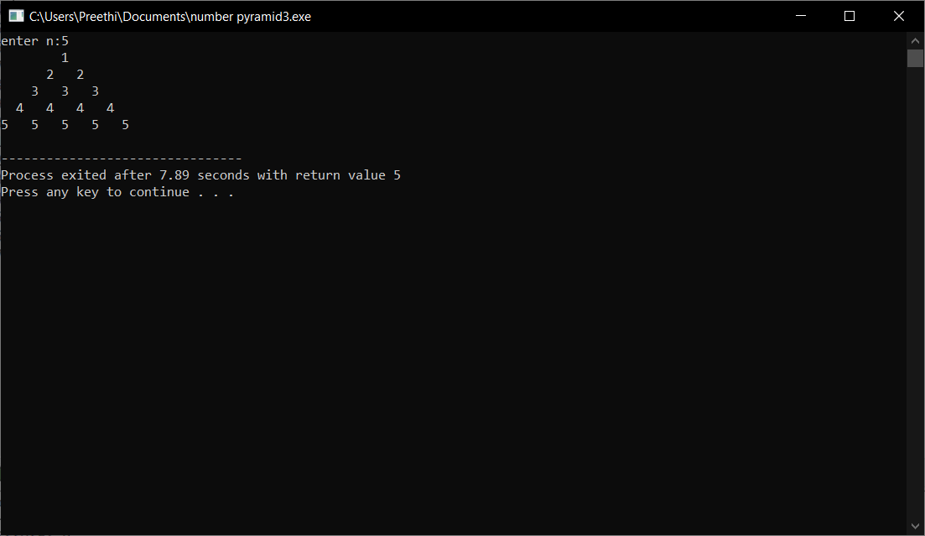

**14.Print the following pyramid**

**1**

**2 2**

**3 3 3**

**4 4 4 4**

**5 5 5 5 5**

**4 4 4 4**

**3 3 3**

**2 2**

**1**

**Pseudocode**

Start

Declare i,j,n

Input n to print number of rows

To print upper pyramid use following loops

For(i=1;i<=n;i++)

For(j=1;j<=1;j++)

Print i

To print lower pyramid reverse the condition

For(i=n-1;i>=1;i--)

For(j=1;j<=i;j++)

Print i

end

**C program**

#include<stdio.h>

void main()

{

int i,j,n;

printf("enter n:");

scanf("%d",&n);

for(i=1;i<=n;i++)

{

for(j=1;j<=i;j++)

{

printf("%d ",i);

}

printf("\n");

}

for(i=n-1;i>=1;i--)

{

for(j=1;j<=i;j++)

{

printf("%d ",i);

}

printf("\n");

}

}

**Output**



**15.print the following pattern**

**\***

**\* \***

**\* * \***

**\* \***

**\***

**Pseudocode**

Start

Declare i,n,j,space

Input n to print number of rows

To print upper pyramid of star pattern run following loops

For(i=1;i<=n;i++)

To print space for(space=1;space=n-1;space++)

Print(“ “)

For(j=1;j<=2*i-I;j++)

Print”* “

To print lower pyramid of star pattern

For(i=1;i<=n;i++)

For(space=0;space<=i ;space++)

Print” “

For(j=1;j<2*2-I;j++)

Print”* “

end

**C program**

# include<stdio.h>

main()

{

int i,n,j,space;

printf("enter n:");

scanf("%d",&n);

for(i=1;i<=n;i++)

{

for(space=1;space<=n-i;space++)

printf(" ");

for(j=1;j<=2*i-i;j++)

printf("* ");

printf("\n");

}

for(i=1;i<=n-1;i++)

{

for(space=0;space<=i;space++)

printf(" ");

for(j=1;j<2*(n-1)-i;j++)

printf("* ");

printf("\n");

}

}

**Output**

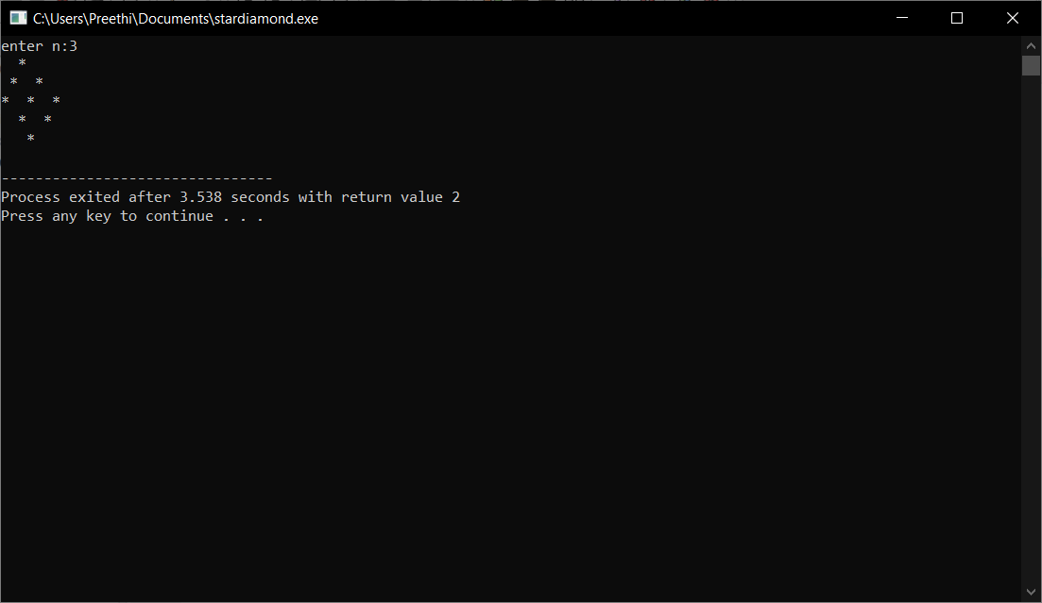

**Done by**

B.preethi

ID:B181356

CLASS:AB-2,305 CSE-1